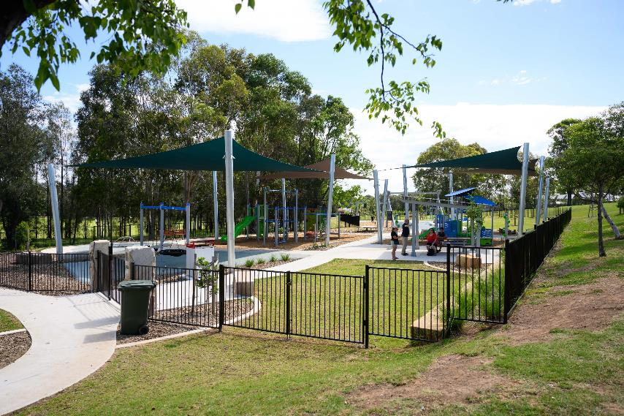

A Social Story for
David Currie Playspace

David Currie Playspace is for families and friends of all ages and abilities. You can play, relax and connect with others.

A Note to Parents and Carers
Social stories are a communication tool to assist individuals and families when visiting new and busy environments.
Using this social story prior to and during your visit can help gain familiarity with types of play and amenities available at David Currie Playspace.

Location
168 Banks Drive Reserve, St Clair
Next to Peter Kearns Memorial Oval
Parking and Accessibility
Car parking on site via Solander Drive
Nearest Bus Stop: ID 275918
Developed in collaboration with
Autism Community Network and reviewed by local families

Table of Contents
- Location Overview
- Parking
- Main Entrance
- Bike Rack
- Swings
- Whirl Spinner
- Large Climbing Equipment
- Picnic Tables
- Small Climbing Equipment
- Trampoline
- Benches
- Flying Fox
- Gym Equipment
- Basketball Court
- Departure

What to Bring
- Hat and sunscreen
- Water bottle and snacks

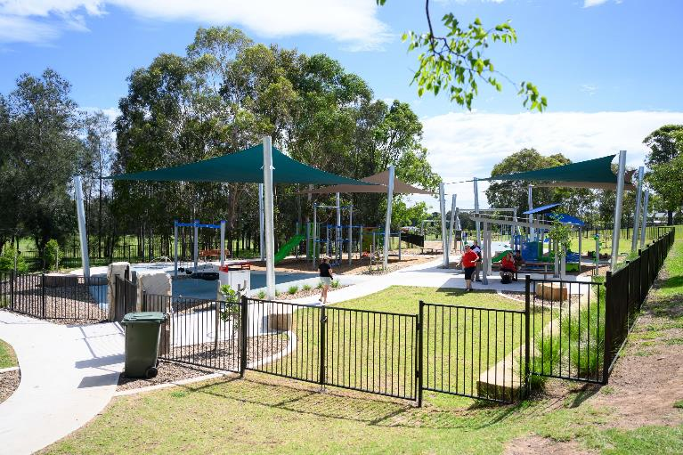

I am visiting David Currie Playspace.

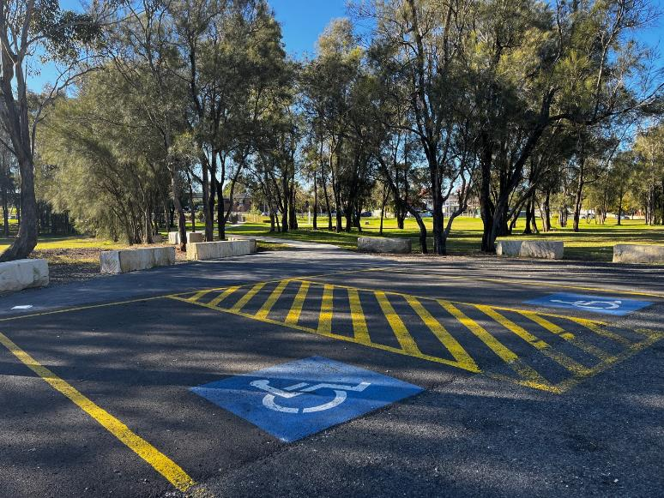

I arrive to the Playspace from the parking area.

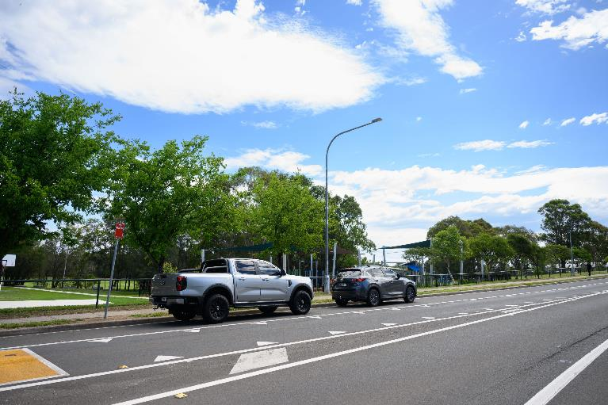

Or I can reach the Playspace from the main road.

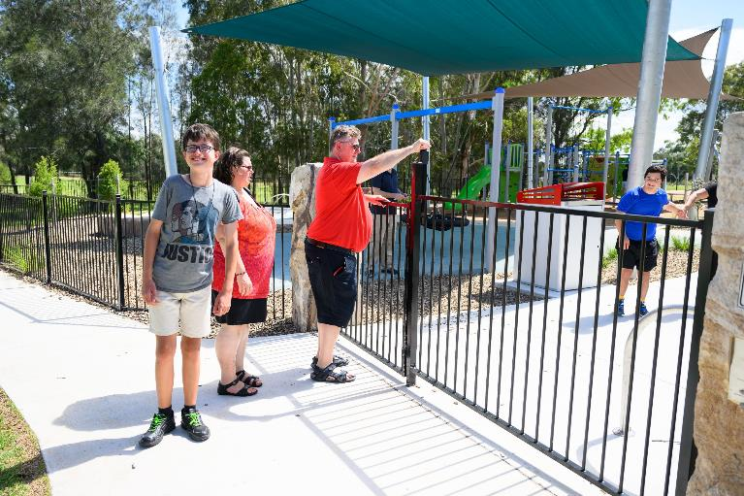

I then enter through the main gate.

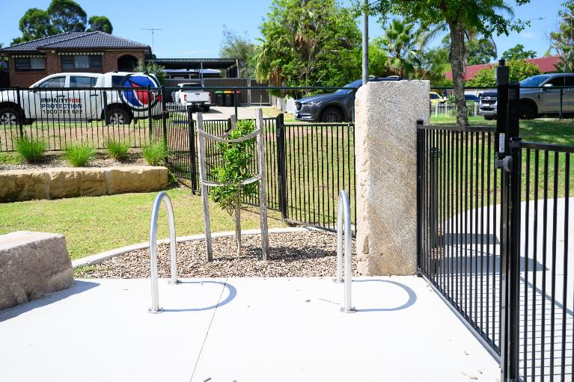

I can park my bike near the entrance.

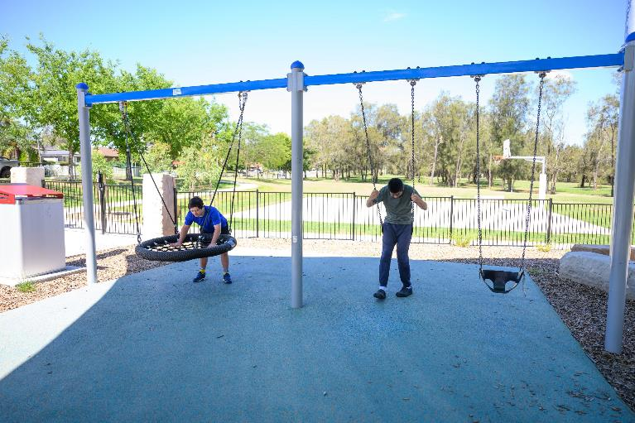

There are several swings that I can use.

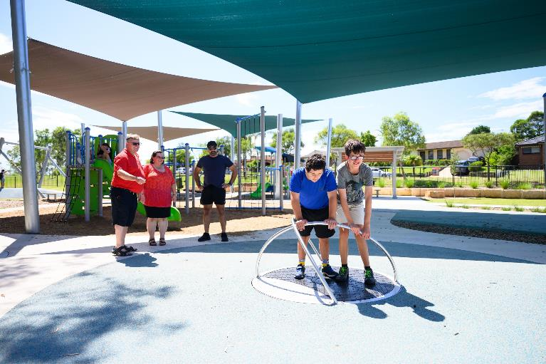

I can try the whirl spinner.

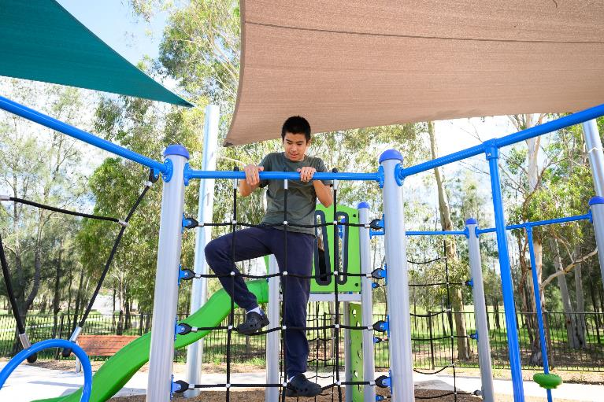

I can play on the large climbing equipment.

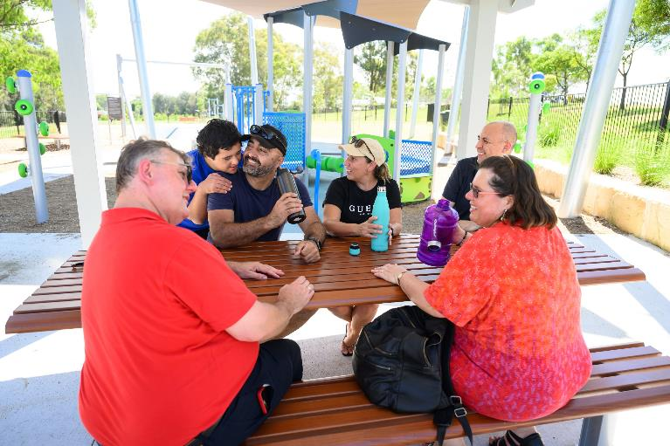

I can have a snack at the picnic table.

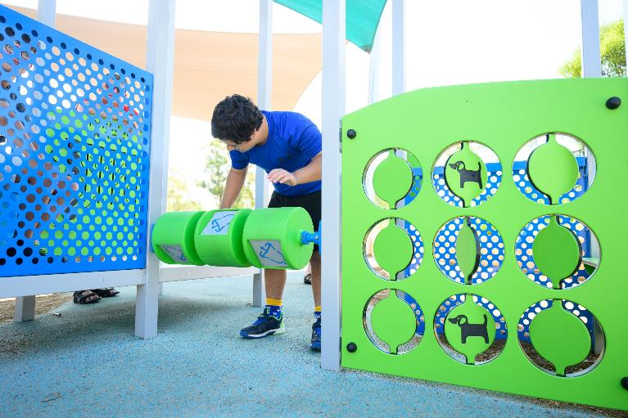

And I can try the smaller play equipment.

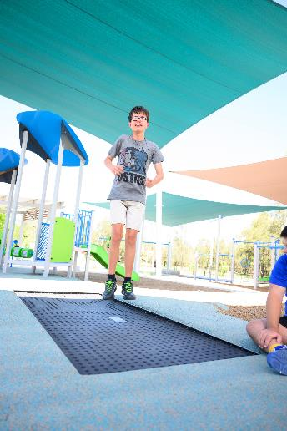

I can jump on the in-ground trampoline.

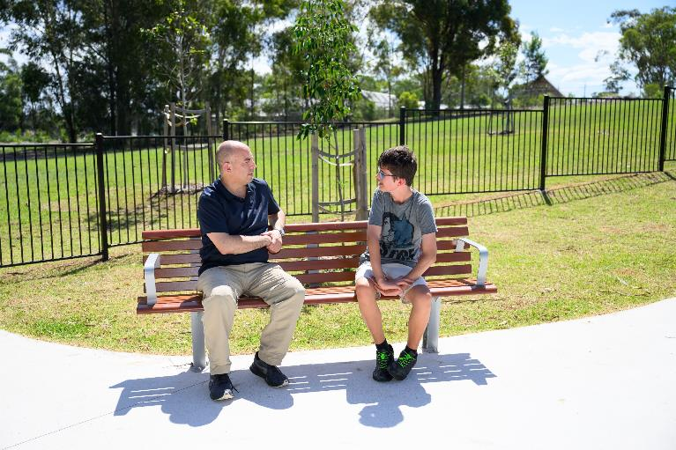

There are benches where I can take a break.

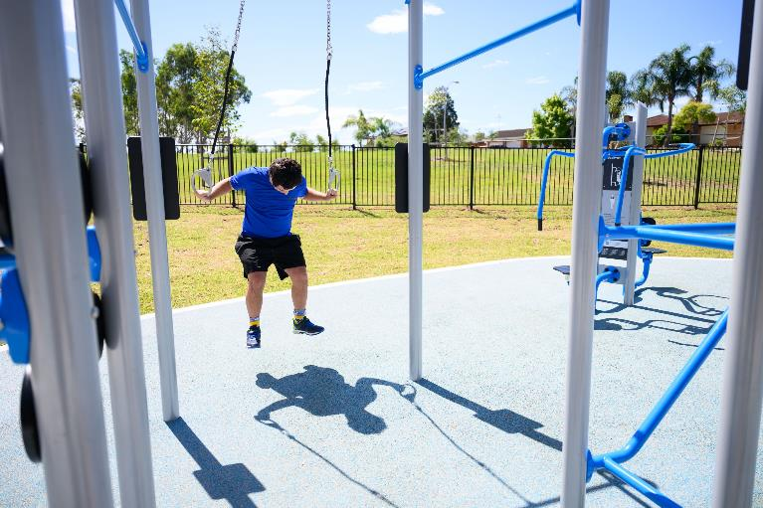

I can exercise using the gym equipment.

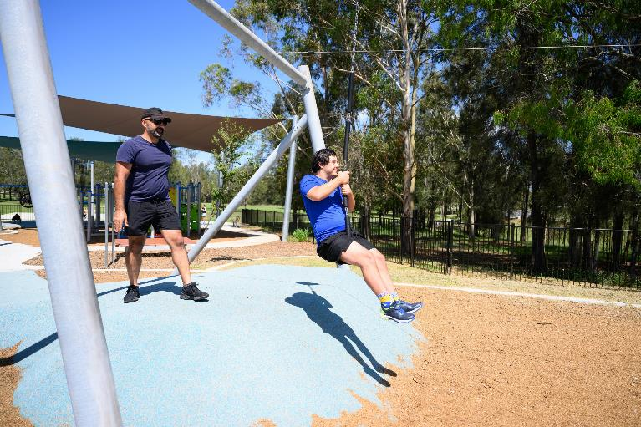

There is also a flying fox I can try.

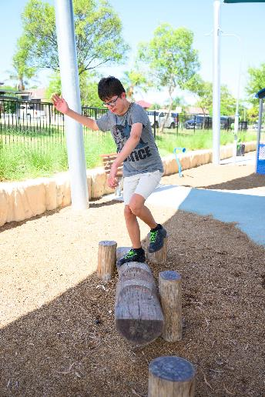

I can try balancing on the logs.

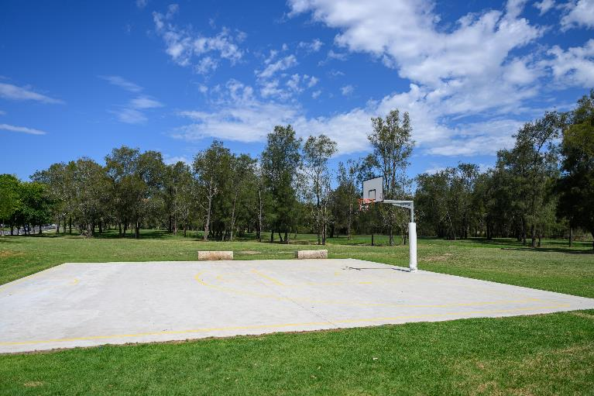

There is also a basketball court next door.

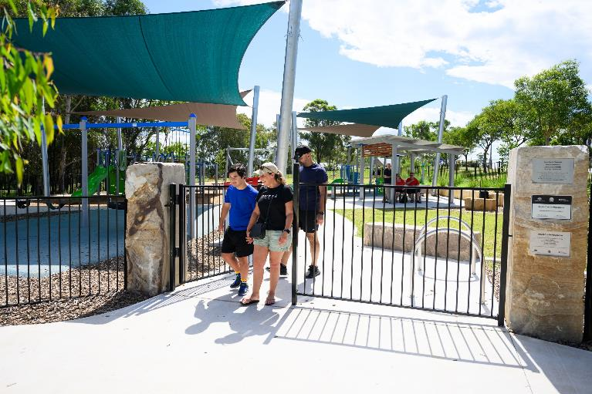

After a busy day, I head home.

Thank you for visiting
David Currie Playspace

penrith.city

