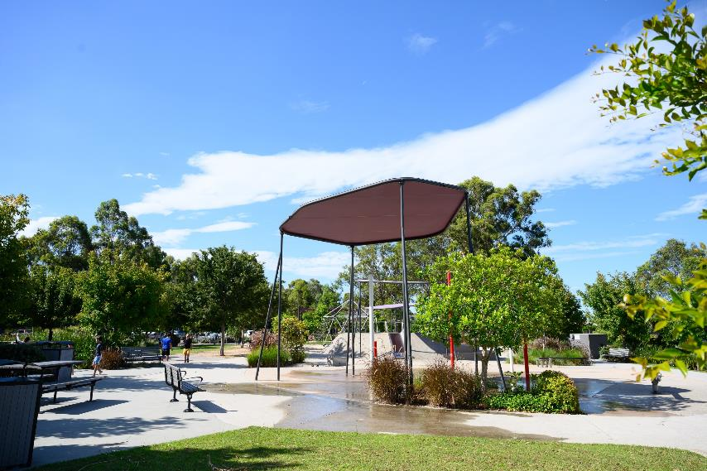

A Social Story for Livvi’s Place,
Jordan Springs

Livvi's Place is an outdoor playspace with a variety of inclusive play options for families and friends of all ages and abilities. You can play, relax and connect with others.

A Note to Parents and Carers
Social stories are a communication tool to assist individuals and families when visiting new and busy environments.
Using this social story prior to and during your visit can help gain familiarity with types of play and amenities available at Livvi's Place.

Location
1 Discovery Way, Jordan Springs
Next to the Northern Road Oval
Parking and Accessibility
Car parking on site via Montague Drive
Developed in collaboration with
Autism Community Network and reviewed by local families

Table of Contents
- Overview and Entrance
- Main Playground Area
- Seesaw and Slides
- Water Play
- Climbing Frame
- Trampolines
- Carrousel & Whirl Spinner
- Swings and Inclusive Swings
- Sensory Corner
- Benches
- Amphitheatre
- Picnic Area
- Basketball Court
- Toilets and MLAK accessible toilet
- Departure

What to Bring
- Hat and sunscreen
- Water bottle and snacks

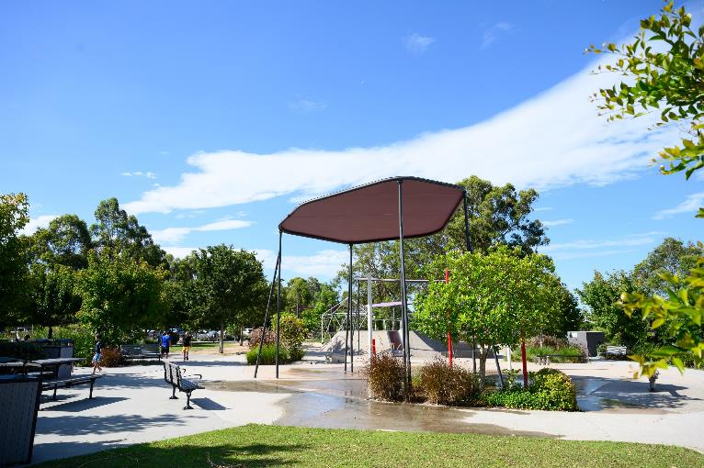

I am visiting Livvi’s Place playground.

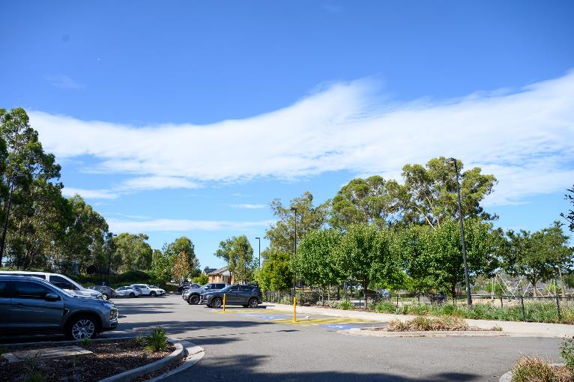

There is a car park next to the playground.

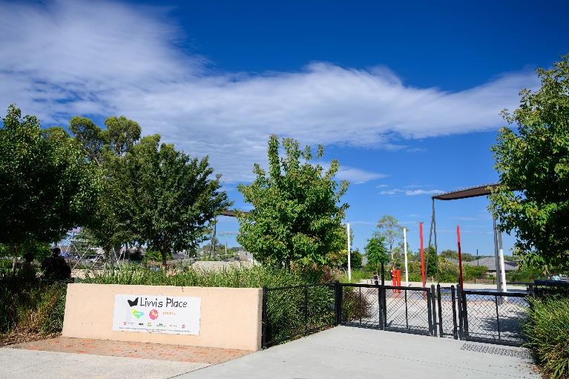

I enter Livvi’s Place through the main gate.

There is a large play area that I can use.

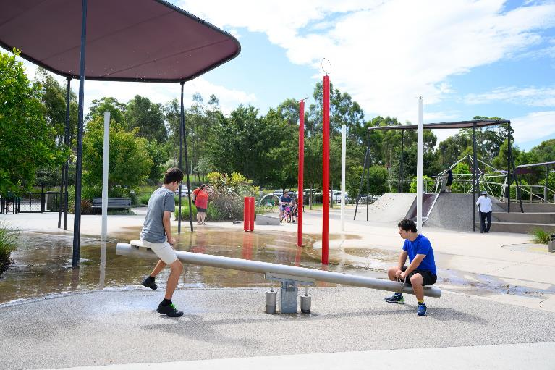

I can try out the seesaw.

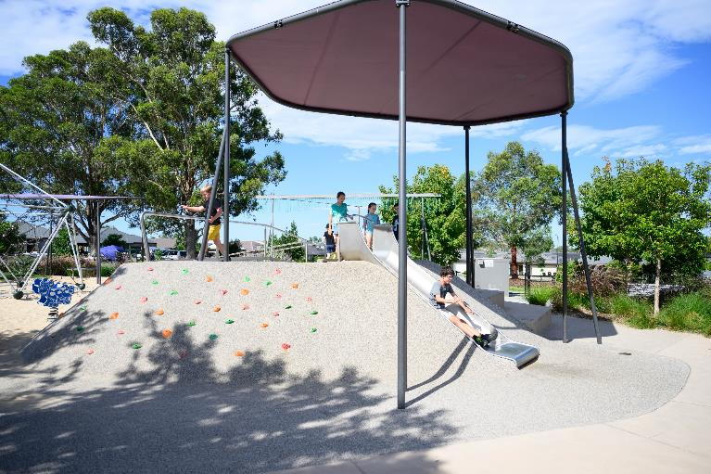

And take turns on the slide.

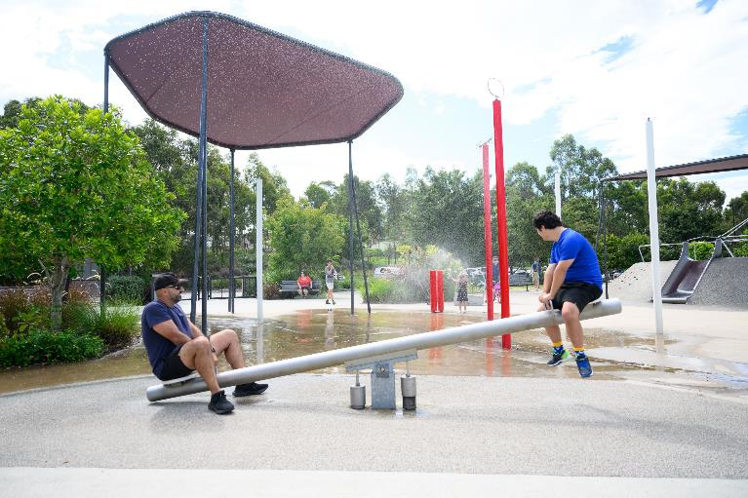

The seesaw turns on the water sprinklers.

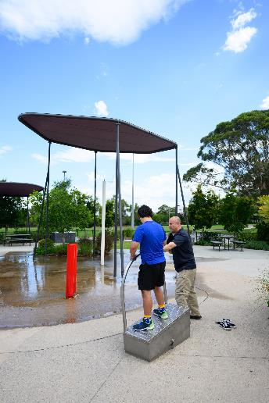

And the balance equipment does the same.

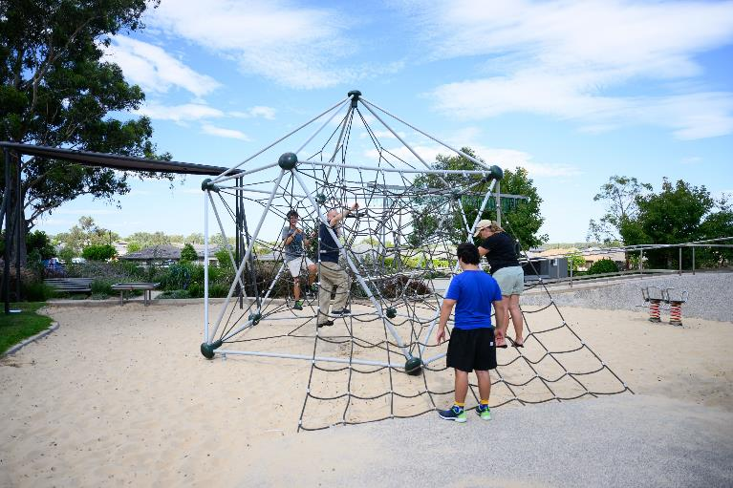

I can play on the climbing frame.

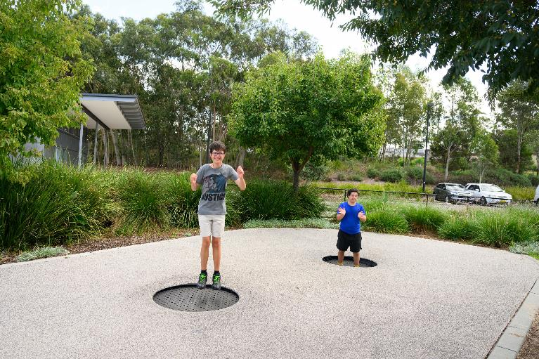

Or jump on the trampolines.

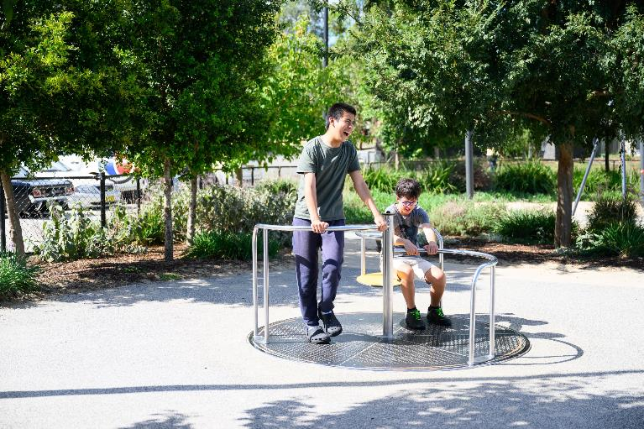

There is a carousel that I can play with.

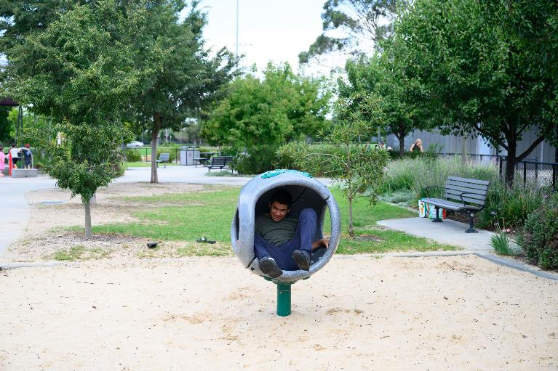

And I can try the accessible pod spinner.

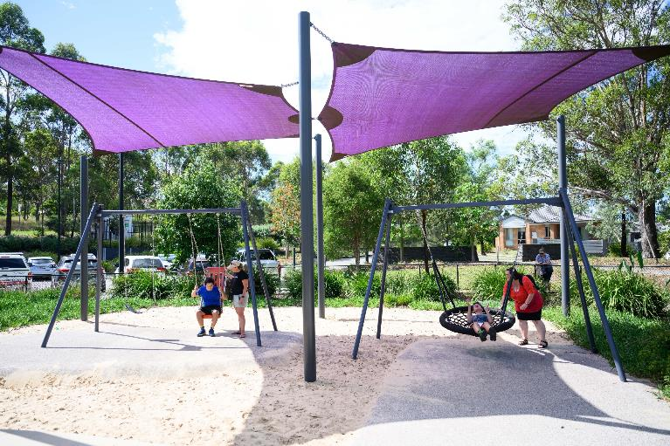

And I can also play with the swings.

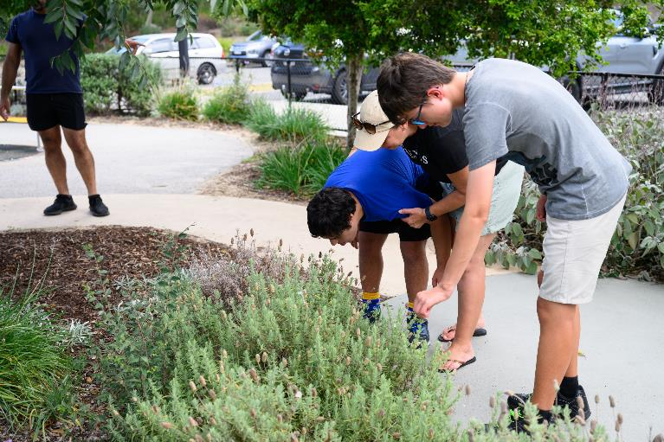

I can explore textures in the sensory corner.

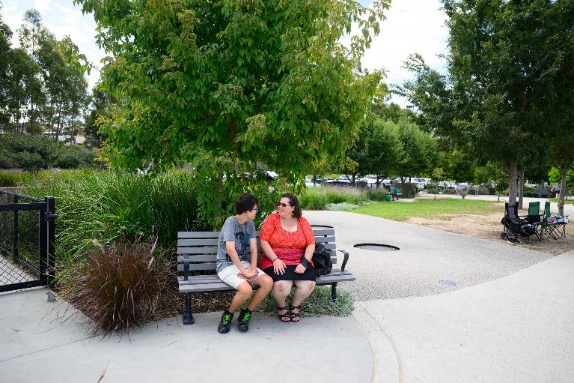

There are benches where I can take a break.

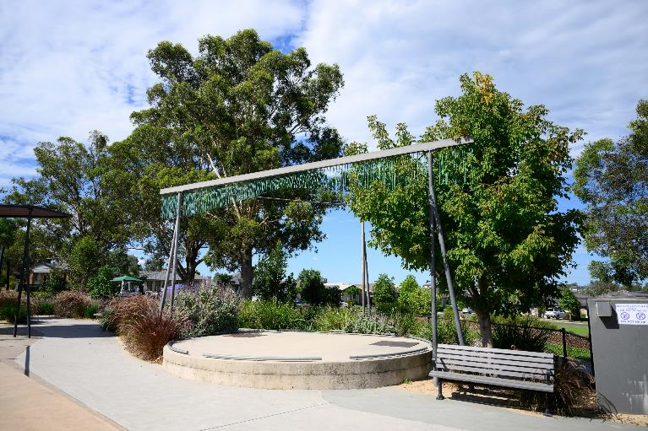

I can perform in the amphitheatre or listen to wind music.

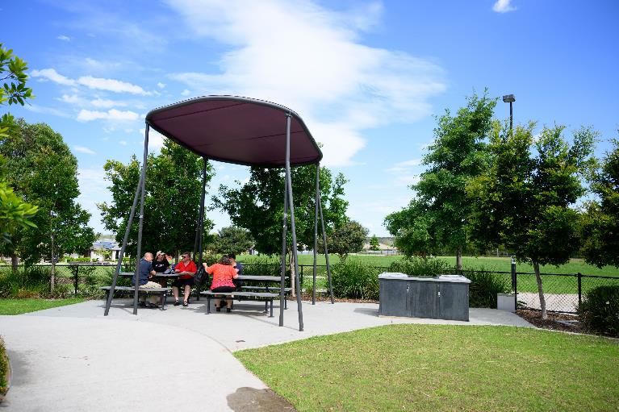

There is a picnic area that I can use.

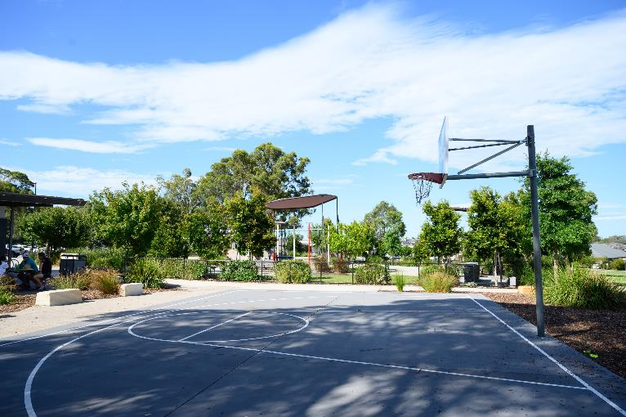

And a basketball court next to the playground.

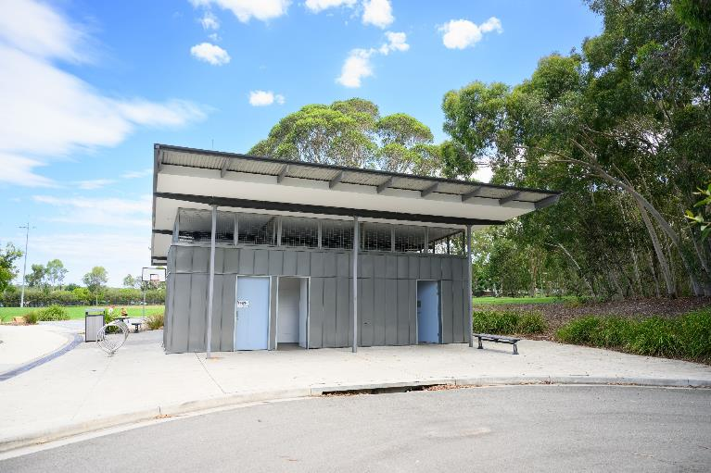

The toilets are next to the playground.

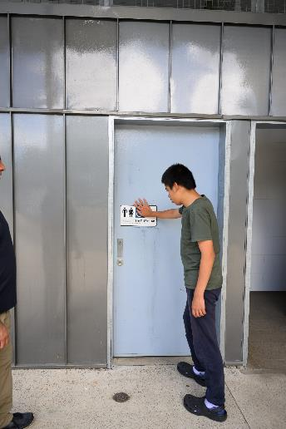

There is also a MLAK accessible toilet.

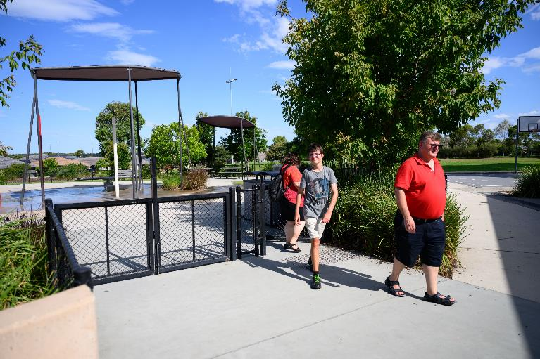

After a busy day, I head home.

Thank you for visiting
Livvi’s Place

penrith.city

